STANDARD HIGH SCHOOL- KAPEEKA
DEPARTMENT OF GEOGRAPHY
SENIOR TWO END OF TERM 1 ASSESSMENT 2024
Time: 1½HOURS

Instructions.
This paper is made up of two sections (A and B)
Section A add up to 20MARKS and B 30 MARKS.
For Section A answer in the spaces with in the question paper and with B you answer in the full scarps provided
All question are compulsory
Use pencils to draw diagrams where necessary
Copying is a murder case and passing is a must.

SECTION A (20 marks)
Question 1
Study Fig. 1 and use it to answer the questions which follow.

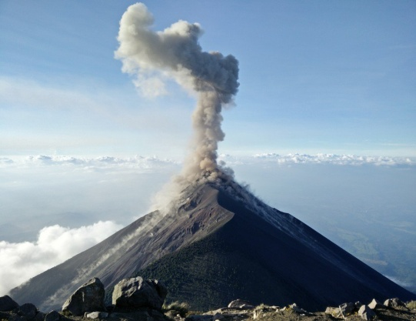
Fig. 1
(Source: Rick ride horses, 2011)

a). What process is taking place in Fig. 1? (2mks)

---------------------------------------------------------------------------------------------------------------------

b). Suggest five problems which may be caused by the process you have identified in (a) above.

-------------------------------------------------------------------------------------------------------------

------------------------------------------------------------------------------------------------------------

------------------------------------------------------------------------------------------------------------

-------------------------------------------------------------------------------------------------------------

------------------------------------------------------------------------------------------------------------

------------------------------------------------------------------------------------------------------------

c) List any 3 examples of mountains formed under that process in fig 1 above.
...........................................................................................
...........................................................................................
.......................................................................................... .
Question 2
For any fieldworks you have ever carried out, either as a group or an individual,
a) State the topic of the study;(2mks)
..............................................................................................................................................
b) mention any five objectives of the study (5mks)
..............................................................................................................................
..............................................................................................................................
..............................................................................................................................
..............................................................................................................................
..............................................................................................................................
C) What are the problems you faced while in the field. (3mks)
..............................................................................................................................
..............................................................................................................................
..............................................................................................................................
..............................................................................................................................
..............................................................................................................................
..............................................................................................................................
..............................................................................................................................
SECTION B
Question 3
A S.6. Vaccist visited her grand parent in Kyerero village surrounding mountain Ngiragongo which they saw pouring out red hot liquid in 2021. She narrated that some commununity members confess that these hot liquid pourings are believed to have formed the rocks which they used to make firm foundations of their houses. However there are some myths that these rocks in the area juts fallen from the sky just like rain and that it was a gift from God thats why they have consistently used them in their day to day activities and as well to earn a living.
Support material.
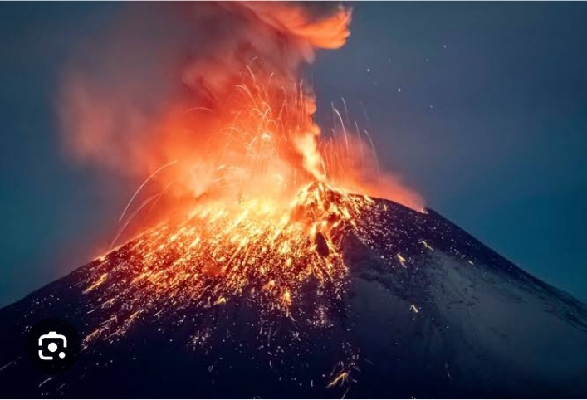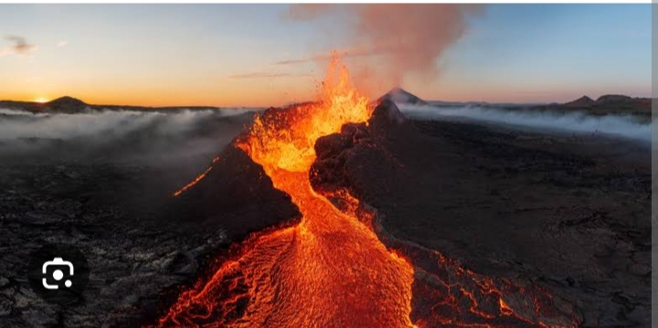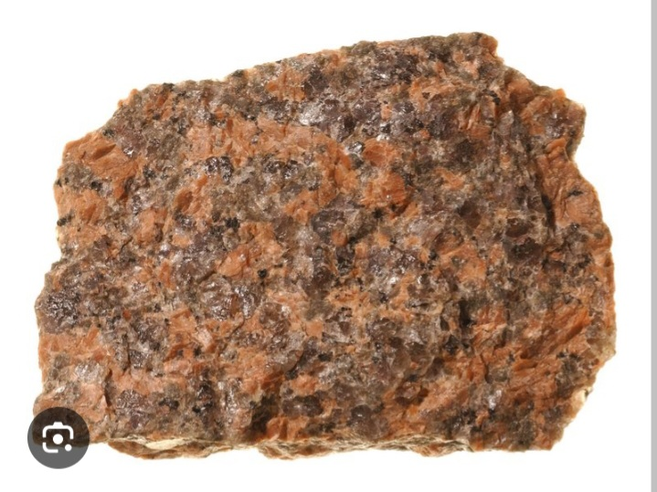
Task.
a) Identify the type of rocks formed based on the scenario. (1mark)
b) State the characteristic features of the type of rock identified above. (5marks)
c) You have been introduced to the community members of Kyerero as a student who has learnt about Geography and you are required to write a letter sensitising community members about how these rocks were formed and as well how they are of value to them. (20marks).
d) List down other types of rocks with their processes of formation. (4marks)
END

